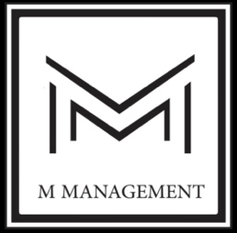 

([www.m-management.co](http://www.m-management.co)) ([www.dcp-int.com](http://www.dcp-int.com))

**Jobs by M Management team**

1. Facade cleaning (aleco-bond, plastic, aluminum…)
2. Facade full renovation
3. Sand blasting
4. Roads Pavement - sidewalks tiling – Alignment
5. Tiles Polishing (marble,ceramic…)
6. Mechanical tiles installation on ropes
7. High water jet pressure cleaning
8. External and internal painting
9. Concrete repair
10. Epoxy painting - epoxy injection – epoxy repair
11. Stamp concrete
12. Gypsum Board installation
13. Tiling, stamp concrete
14. Aluminum installation - glass work
15. All kinds of waterproofing systems
16. All kinds of Wood works
17. Upholstery for furniture
18. Electricity
19. Electro mechanical
20. Sanitary
21. Pools renovations full scope
22. Sports courts flooring
23. Block work
24. Sound proofing insolation
25. Thermal insulation
26. Plaster work
27. Brick installation
28. HVAC installation
29. Welding and steel rebars work
30. Hot waterproofing applications
31. Thermal camera water leakage detection - humidity testing - soil humidity testing
32. Window cleaning and window deep cleaning (internal and external)
33. External floor cleaning (basalt...)

* We supply and apply all DCP full range of construct material **by rope access**